Student names, University
Rebecca Siebeneicher, ZHAW
Spyridon Margomenos, ZHAW
Anika Heim, ZHAW

Topic
Fish Population Dynamics in Lake Constance

Illustration
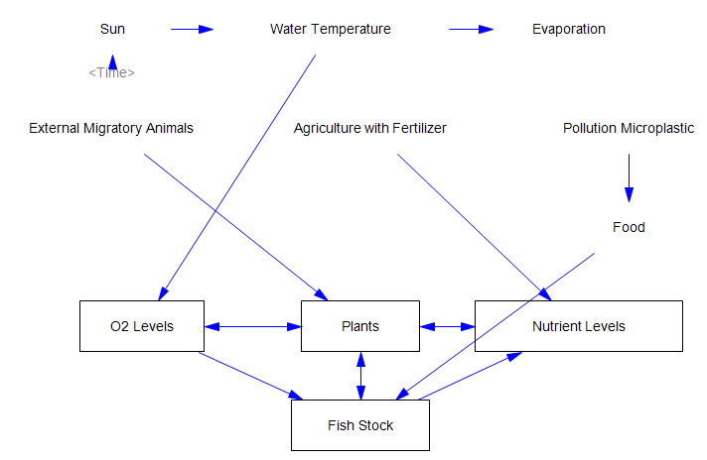

Model Aspects:
The model should represent the development of the fish population in Lake Constance. Initially, we will only consider the following factors in the model: fish population, nutrient levels, plants, and Oxygen levels. If this works and we still have enough time we will start adding factors from outside the lake (sunlight, agriculture, fishing, pollution, …).

Input
- Fish population at starting time
- Plants
- Nutrient levels
- Oxygen levels

Output
- Fish population over time

Data available:
Fish population in Lake Constance:
https://www.fischereistatistik.ch/de/statistics?tt=%204&dt=0&at=0&st=0&dp=0&ar=CH&wt=1&th=10&un=0&in=0&yr%5Bfrom%5D=2014&yr%5Bto%5D=2018&sp=100102
https://www.aquaetgas.ch/wasser/gew%C3%A4sser/20230714_ag7_8_fischbest%C3%A4nde-des-bodensees/
https://www.ibkf.org/wp-content/uploads/2020/10/IBKF_Barschbericht_Fangjahr_2019.pdf

Plant levels:
https://www.igkb.org/medien/faktenblaetter/unterwasserpflanzen-im-bodensee-mai-2021 (not in numbers but some descriptive information)

Nutrient levels:
https://www.igkb.org/medien/faktenblaetter/phosphor-im-bodensee-oktober-2018 (phosphor)

O₂ Levels and Water Temperature in Lake Constance: https://www.igkb.org/medien/faktenblaetter/zirkulation-im-bodensee-oktober-2018

Water quality in general:
https://opendata.swiss/de/dataset/gewasserqualitat-in-bodensee-thur-und-murg/resource/19ff83b4-40ec-4caf-864b-b6caf7f5cb4f

Hypotheses:
- The more O₂ there is in Lake Constance, the more fish there will be.
- The more plants there are in Lake Constance, the larger the fish population will be.
- If O₂ levels are high, nutrient levels will increase.

